THE LAWN MOWER SHIOP HOME OF THE ROOTHOG

Super-Tooth Roothog

PATENT US 8,387,261,82

MADE IN THE UNITED STATES OF AMERICA

\

DO NOT OPERATE or ASSEMBLE PRIOR TO READING THIS
SAFETY MANUAL,
GENERAL WARNINGS, OPERATING AND ASSEMBLY INSTRUCTIONS

GENERAL TIPS ON THE USE OF THE SUPER-TOOTH ROOTHOG:

GENERAL CAUTION: Read this entire SUPER-TOOTH ROOTHOG Operator’s Manual before attempting to install any attachment. Keep bystanders away 15m (50 foot) when operating. Always
wear safety gloves and safety apparel during operations. Keep feet and hands away from cutting head. Failure to follow the warnings could result in serious injury. Never handle, attempt to change or remove t the cutting head while engine is ON or RUNNING.
Inspect area of operation and remove all foreign objects such as glass, cans, rocks, metals,
wires, etc. prior to use.
Be alert to vibrations or damage to your cutting head or gas powered equipment, turn engine off
And inspect for damage.
Use the SUPER-TOOTH Roothog cutting head at medium to slow speeds (RPMs)

DO NOT ATTEMPT TO USE ON:
Manual lawn edgers, Electric lawn edgers, Battery operated edgers, Gas powered PUSH Edgers
String trimmers,
If you are using the wheel attachment on your edger, please remove before using.

DANGER WARNING: Do not attempt to make any adjustments or modifications to the
cutter head or Shield Assembly. Unauthorized modifications can lead to premature failure of
your Super-Tooth Roothog and could cause serious injury as well as voiding any and all warranties.

DANGER WARNING: Always use eye and body protection while operating this product.
Use of this product in applications other than specified can cause bodily injury.
The correct safety guard and adapters must be in place at all times.
Follow installation and operation instructions of this product and your lawn edger operators
and safety manual.
Failure to follow these warnings and warnings listed in your edger operators and safety manual
may result in serious personal injury.

Page 2

How to Assemble cutter head and shield.

Look at you Super-Tooth Roothog package and identify all the parts listed for the Hub (See Parts Lists)
and the illustration in the diagram below.
The Hub has been pre-assembled and ready to receive the appropriate adapter for the edger you have.
Care must be taken as to not disturb the current cutting pattern of the teeth. If the chain loops have
been shaken loose during shipment, reinstall using the recommended Cutting head pattern below. 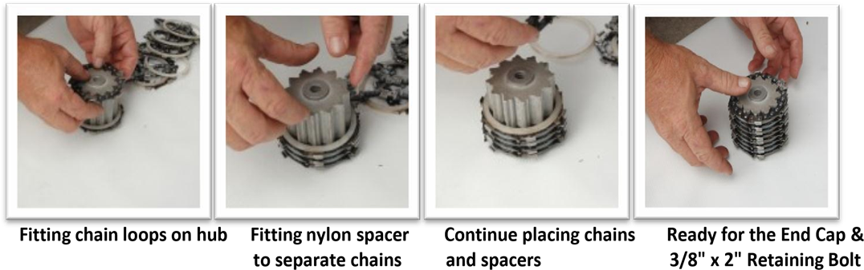
Fitting chain loops on hub Fitting nylon spacer to Continue placing chains Ready for the End Cap and
Separate chains and spacers 3/8’ x2’ Retaining Bolt

Super-Tooth Roothog Cutter Head Assembly
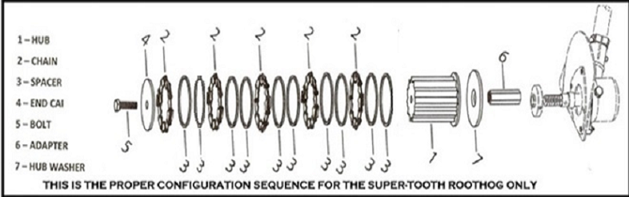

Page 3
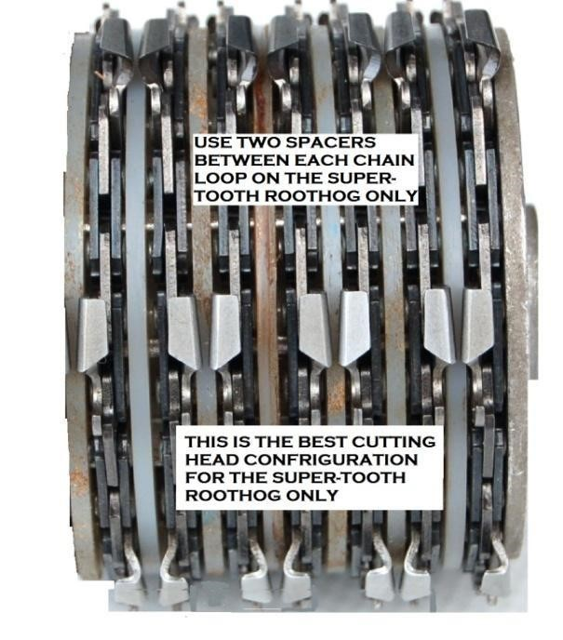
ASSEMBLY SEQUENCE
FOR THE SUPER-TOOTH
ROOTHOG CUTTING HEAD

Select the appropriate adapter from the three provided. If the adapter you have selected has a notch on it.
Insert the notch side into hub assembly first. If it is one or the other two insert largest hole end
into Hub first. If the adapter you choose does not tighten up against the Inner Washer (Item - 7),
do not force the adapter, (PLEASE NOTE: There will be play in between the chains This is designed so that
the wood particles do not get caught between the chains)
Contact ROOTHOG.LLC Customer Service (904)-813-4902 for assistance.

To finish the Hub assembly, place the End Cap (Item 4) on and secure with 3/8" x 2” bolt through the hub
so, it screws into the adapter and securely tighten bolt (Item 5). If the 3/8" bolt does not easily threads
into the adapter, do not force, contact ROOTHOG.LLC Customer Service @ 904-813-4902 for assistance.

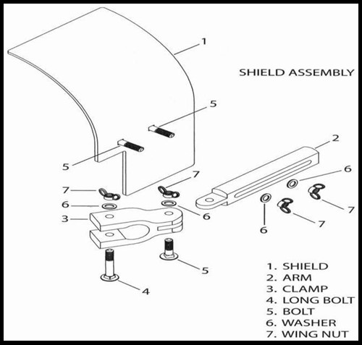

Shield Assembly
Page 4

Locate the Shield Arm (Item 2) and Shield Clamp (Item 3) and slide the tab end of the arm into the
slot of the shield clamp and secure finger tight with Bolt (Item 5), Washer (Item 6) and Wing Nut (Item 7).

Attach the Shield (Item 1) to the long open slot of the arm with two Carriage Bolts (Item 5), Washers
(Item 6) and Wing Nuts (Item 7). Secure only finger tight.

Attach entire Shield Assembly to the power shaft of edger 12" above the cutting head using
a Carriage Bolt (Item 4), Washer (Item 6) and Wing Nut (Item 7). Mounting the Safety Shield 12"
above the cutting head will allow you to see where it is cutting. Secure only finger tight.

Adjust the Shield Clamp and Shield up/down/in/out to ensure the shield is aligned completely over
the SUPER-TOOTH ROOTHOG. The two RED ARROWS on the shield should be centered over the
cutting head as a guide for cutting the tree root.

SPECIAL NOTE: Prior to operating the Super-Tooth Roothog, be sure to tighten the edger
handle to prevent movement and if equipped with a depth wheel, either remove or rise and secure the
wheel in the up position.
Secure all Wing Nuts securely in place.

SUPER-TOOTH Roothog is designed to work with the grain of the tree root. Shave down the tree root
along the length of the root, not sideways or crosscut.

Use the SUPER-TOOTH Roothog cutting head at medium to slow speeds (RPMs).

If more throttle is needed, push down on the cutting head to keep the edger running at
a medium speed. The cutting head actually works better at a slower speed because it allows the
cutting teeth time to bite into the root.

The Super-Tooth Roothog has specifically designed cutting teeth that shaves down cypress knees,
Banyan, Ficus and all other types of tree roots. The Super-Tooth Roothog is designed to work on
residential and commercial edger’s. However, it is recommended that a commercial grade edger be used.

:
SHAVING DOWN A CYPRESS KNEE USING THE SUPER-TOOTH ROOTHOG

The Super-Tooth Roothog has the specially designed carbide-capped chainsaw teeth that
effectively shaves down Cypress Knees

Page 5

CYPRESS ROOTS

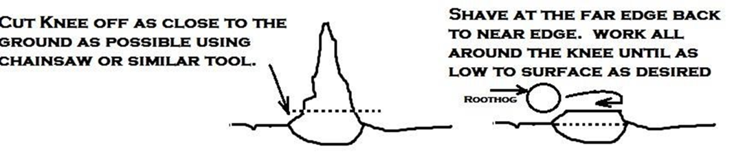a

GENERAL WARRANTY: The manufacturer makes no representations about the effect of cutting roots
to host tree, or surrounding plants.
Only a certified arborist should make the determinations about the consequences
of shaving a tree root, or tree root system.
The Super-Tooth Roothog and all its parts (except chains) are warranted from date of purchase for any breakage.
Any individual part or multiple parts that fail because of manufacturing defects will be replaced at no cost.
. Any misuse or abuse of the product will void all warranties.

RENTAL USE: NON-WARRANTED. All warranties are null and void if the Roothog is used as a rental item.

RETURN/CANCELLATIONS:
If the Roothog does not perform as advertised it may be returned within 30 days of your original order
date for a full refund (less S&H) provided that no damages to the product has occurred and has not been used.
You must first contact Roothog.LLC at (904)-813-4902 to obtain Return Authorization.
and to ensure proper crediting.
All return shipping charges are the responsibility of the purchaser.
Allow 15 business days for a credit (less S&H) to be applied to your purchase. You will be notified by e-mail
when the credit is applied.
Manufacturing defective parts will be replaced and shipped at no cost to purchaser. All defective parts
must be returned prior to any replacement parts being shipped.
ROOTHOG.LLC will be responsible for return shipping charges.

Chain Sharping Done By

Rapco Industries, Inc. Roothog LLC/The Lawn Mower Shop LLC
6000 NE 88th Street 100 Woodside Drive
Suite D-104 Orange Park, Fla 32073
Vancouver, WA 98665-0982 (904)813-4902
(800) 959-6130 Roothogone@Gmail.com
www.roothogone.com
TLMSorangepark@Gmail.com
Page 6

